Q2.Create a procedure to increase salary of employees in department 30. The salary increase is 20% for employees earning less than 3000 and 10% for more than 3000

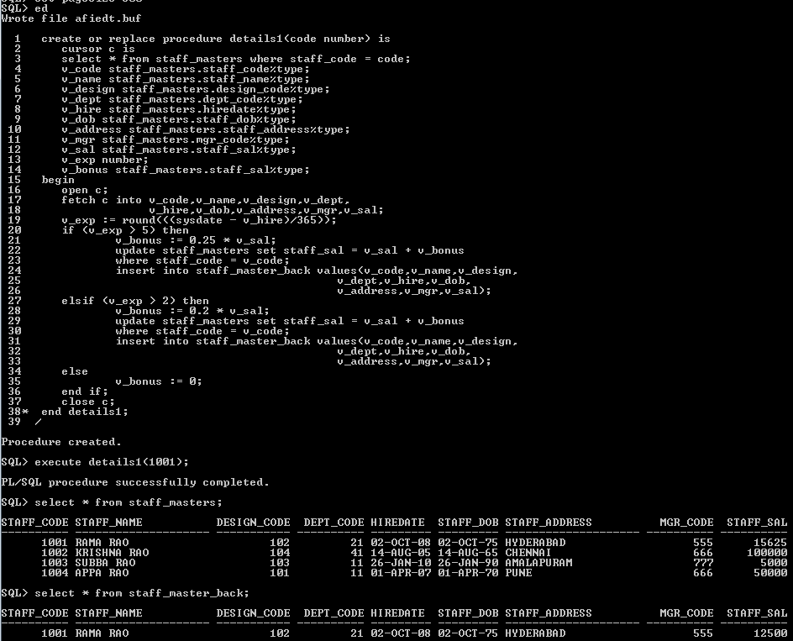

Q3. Write a function to accept empno & update salary as salary+commission only if the employee is a sales representative else salary should not be updated. If comm=0 or null update commission by 5% of salary .return the calculated values

OUTPUT:

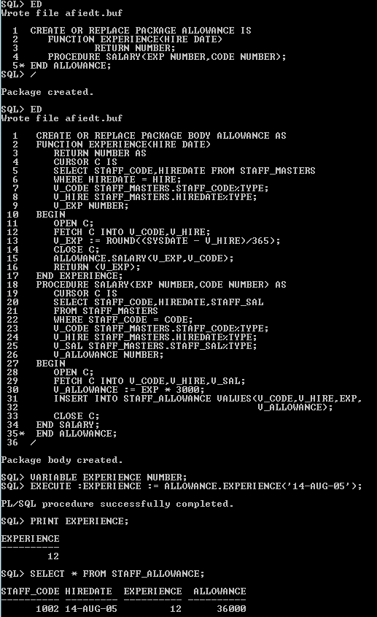

Q5. Design a report to display employee name,salary,total salary for every job within a departmentAnd the grand total salary. The hadings of columns should be formatted. The salary values should be displayed as $99,999.00

COMMANDS:

To display salary in the format $99,990.00:

COLUMN SALARY FORMAT $99,990.00

To display total salary :

SQL> COLUMN DUMMY NOPRINT

SQL> COMPUTE SUM OF SALARY ON DUMMY

SQL> BREAK ON DUMMY

SQL> select FISRT_NAME,LAST_NAME,SALARY,DEPARTMENT_ID FROM EMPLOYEES ORDER BY DEPARTMENT_ID;

OUTPUT: 